**RE (Robotic Enterprise) Framework**

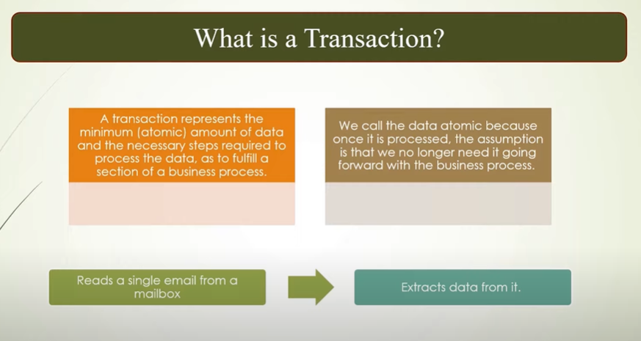

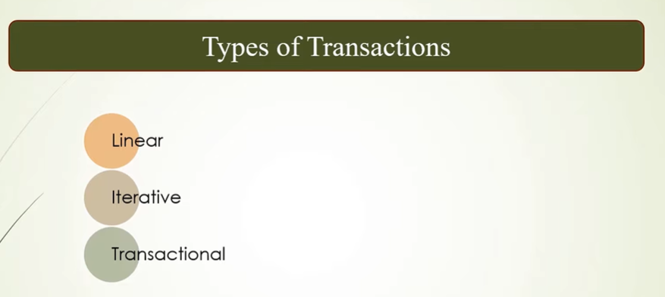

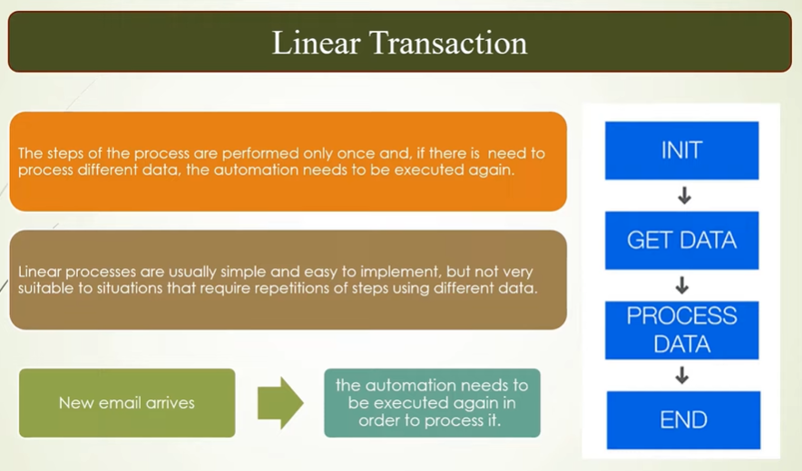

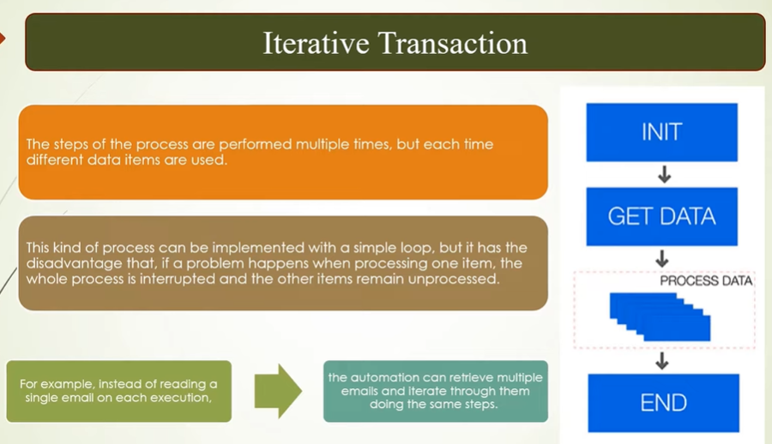

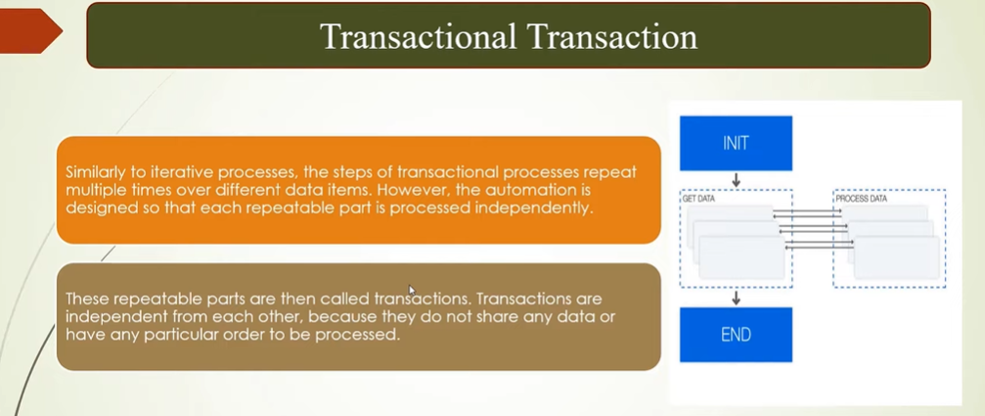

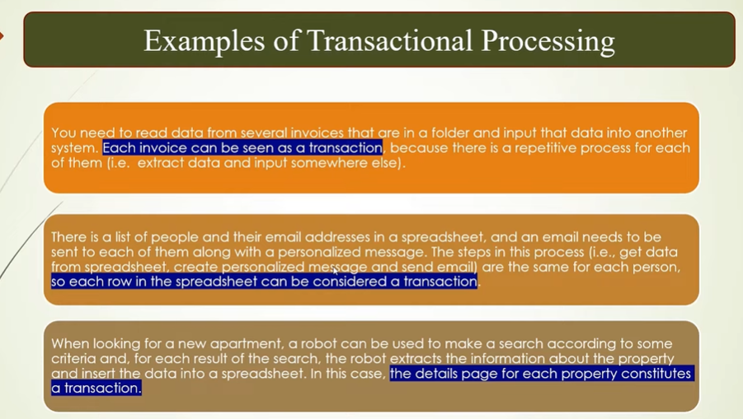

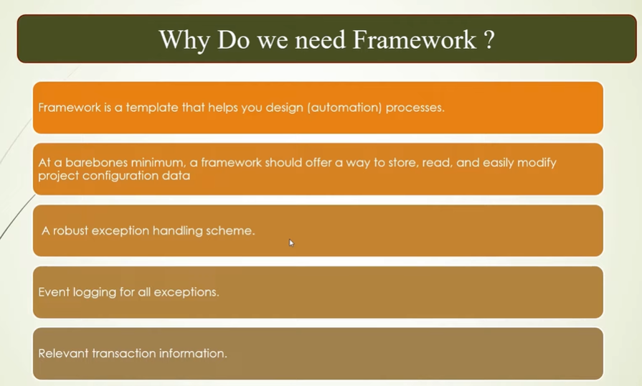

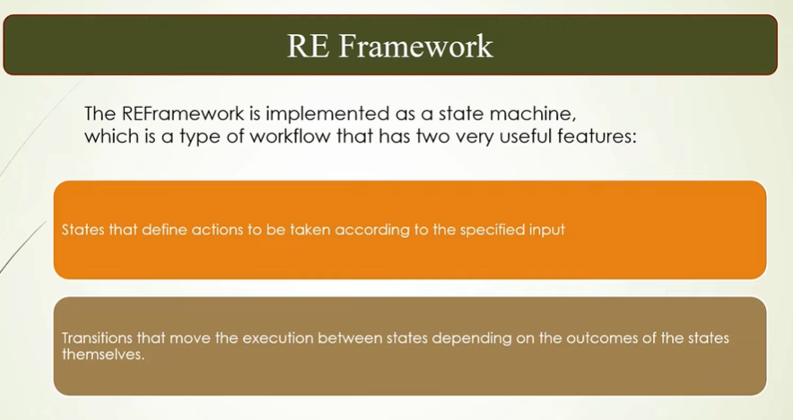

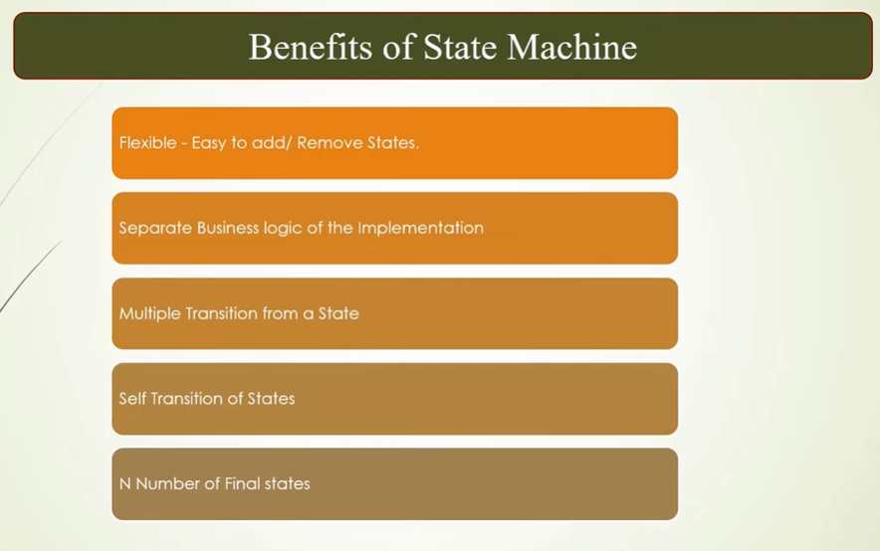

**How many default states in RE Framework?**

🡪 **4 default state**s are there in RE framework

1. Initialization 2) Get transaction data

3) Process transaction 4) End Process

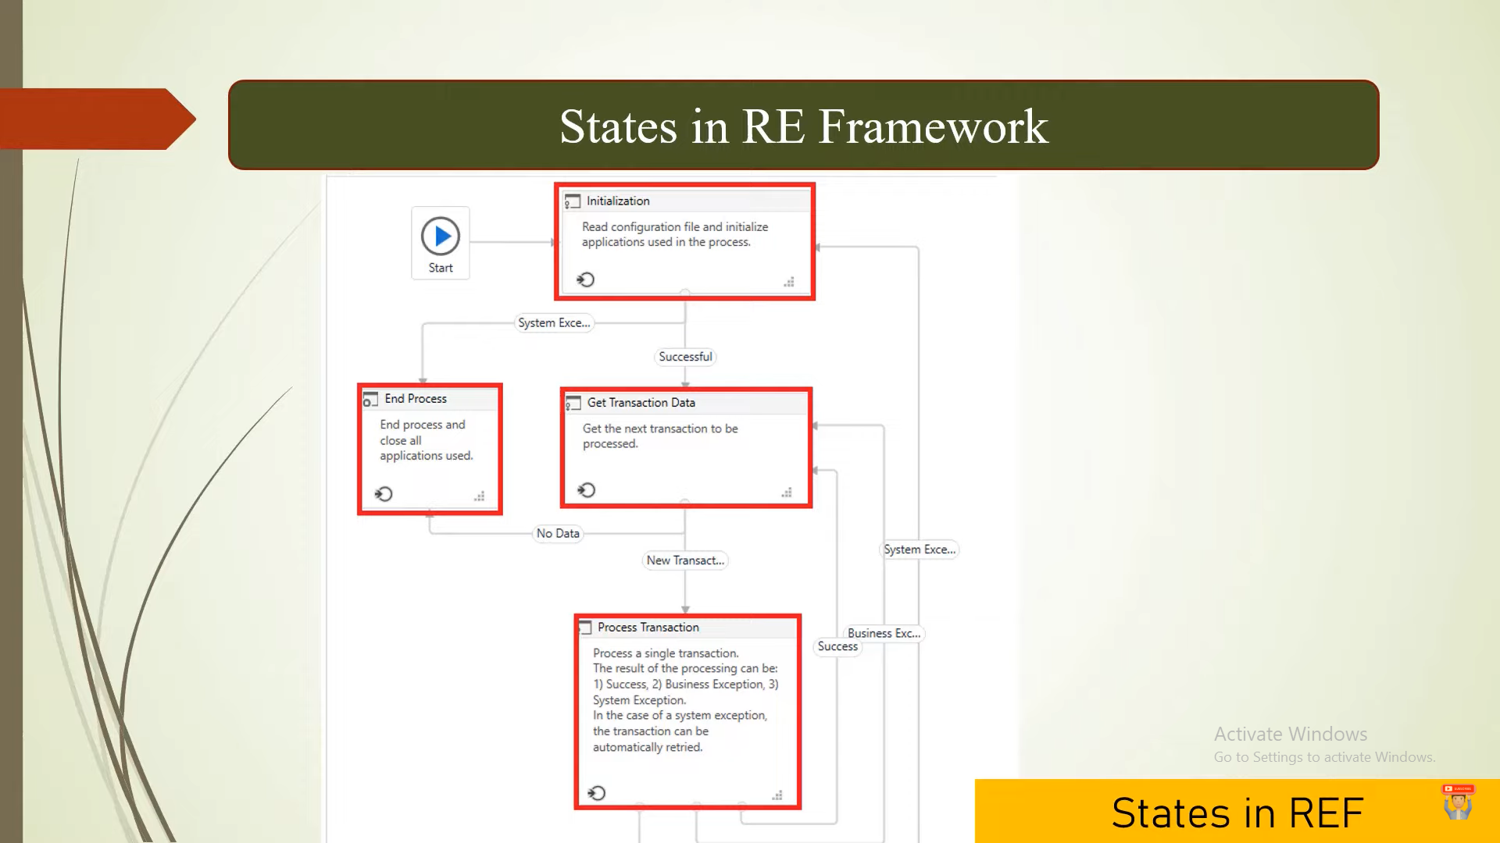

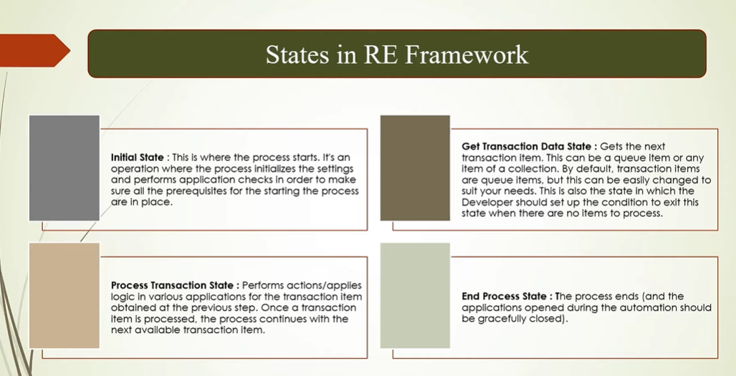

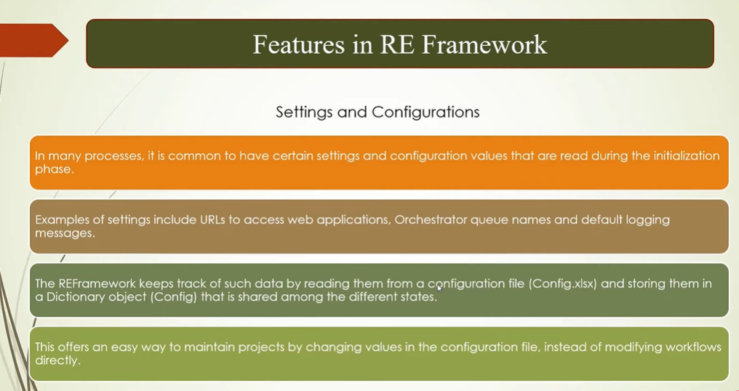

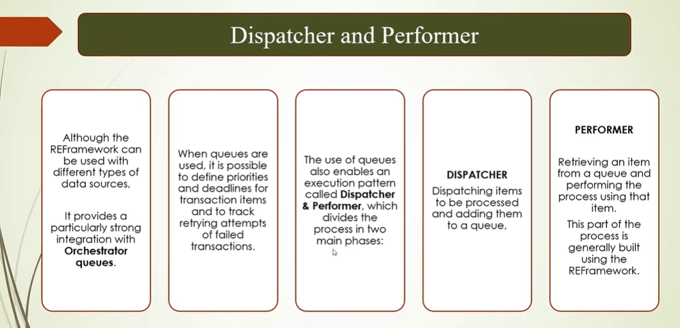

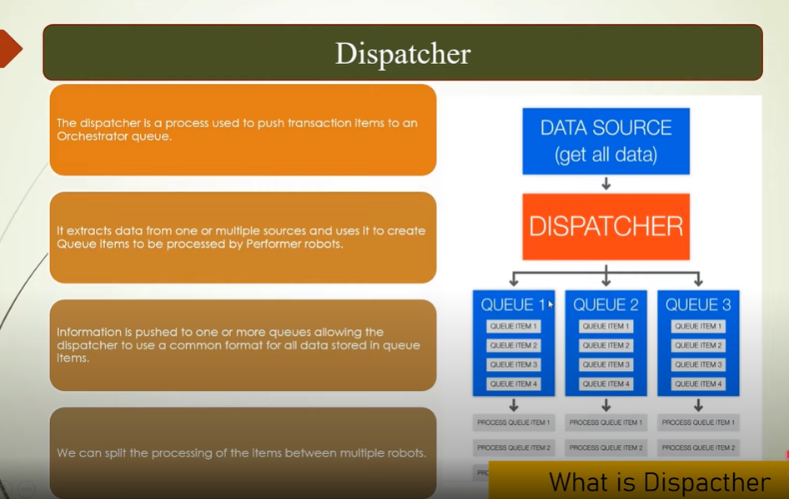

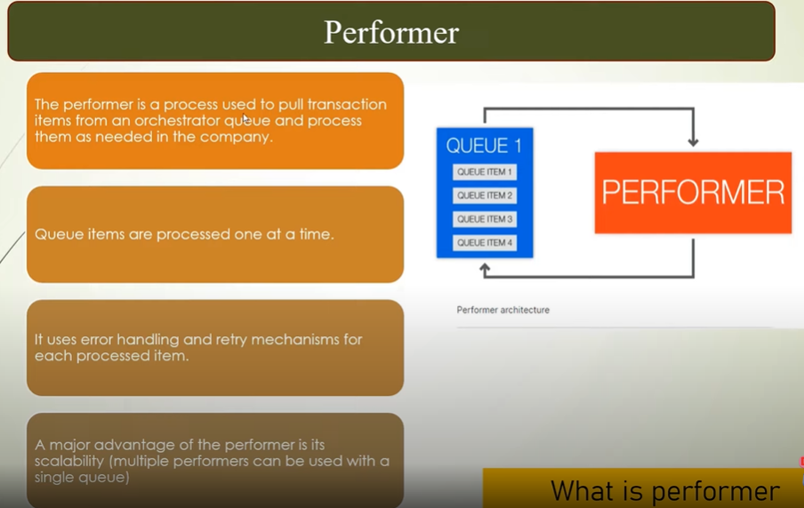

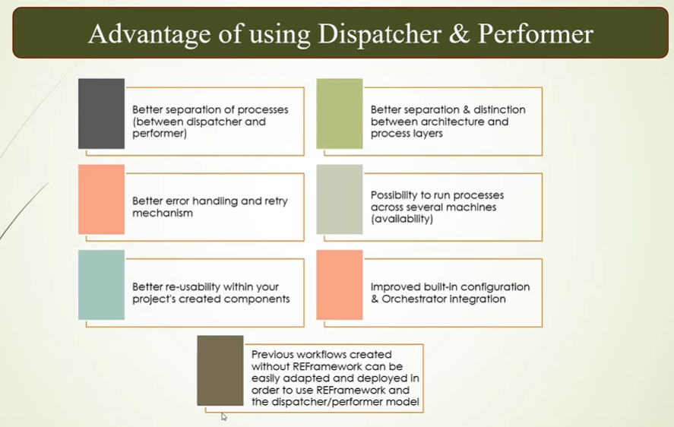

**Note:** 3 sheets are there in config file in data folder. It will work like Key Value pair.

**Note:** Config file is a Dictionary as String and Object.

1. Settings 🡪 We can store our values in settings sheet. (3 column is available in settings sheet. **Name, Value and Description**.)
2. Constants 🡪 Same as constant variable.
3. Assets 🡪 Assets in Orchestrator.

**Exception Handling:**

1. System Exception.

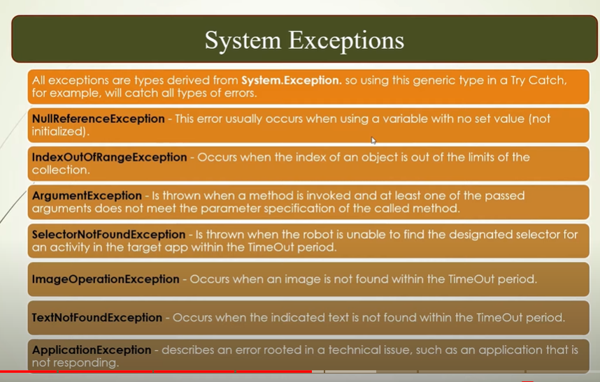

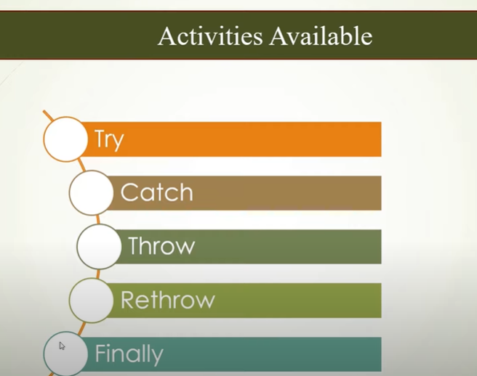

1. Business Exception.

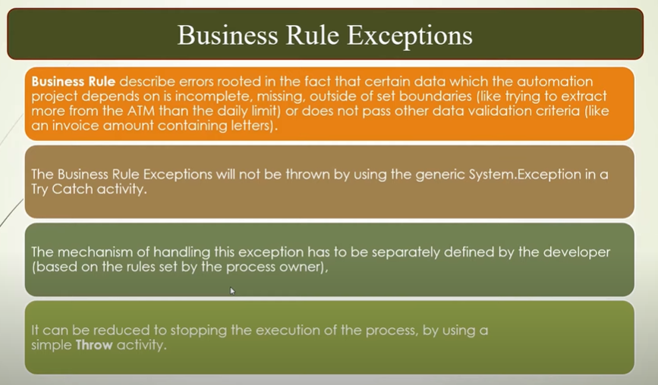

Examples:

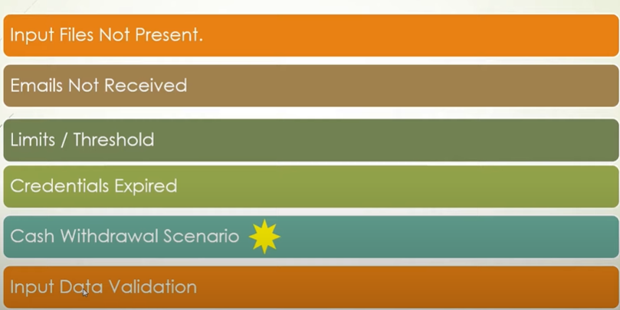

**System Exception** is the parent of all the exceptions.

We can use System exception in catch block if we don’t know the type of exception.

We can throw the business exception in try block. And we need to catch the throwed message to in catch block.

If we want to **throw** the child workflows exception to the parent workflow, then we have to use **Rethrow** exception in **catch** block to the main.xaml then we should handle the exception in main.xaml.

**Rethrow** will give the same message as **Throw** to the parent workflow.

**ContinueOnError:** Is same as exception handling.

This is the properties, available in properties panel for every activity.

Two ways we can do this.

1. Container level 🡪 if we add multiple things in one container and in containers property we gave true value to ContueOnError so it will proceed with next things even in containers things facing any issue/error.
2. Individual level🡪 we can set this for individual set also.

**Global Exception Handler:**

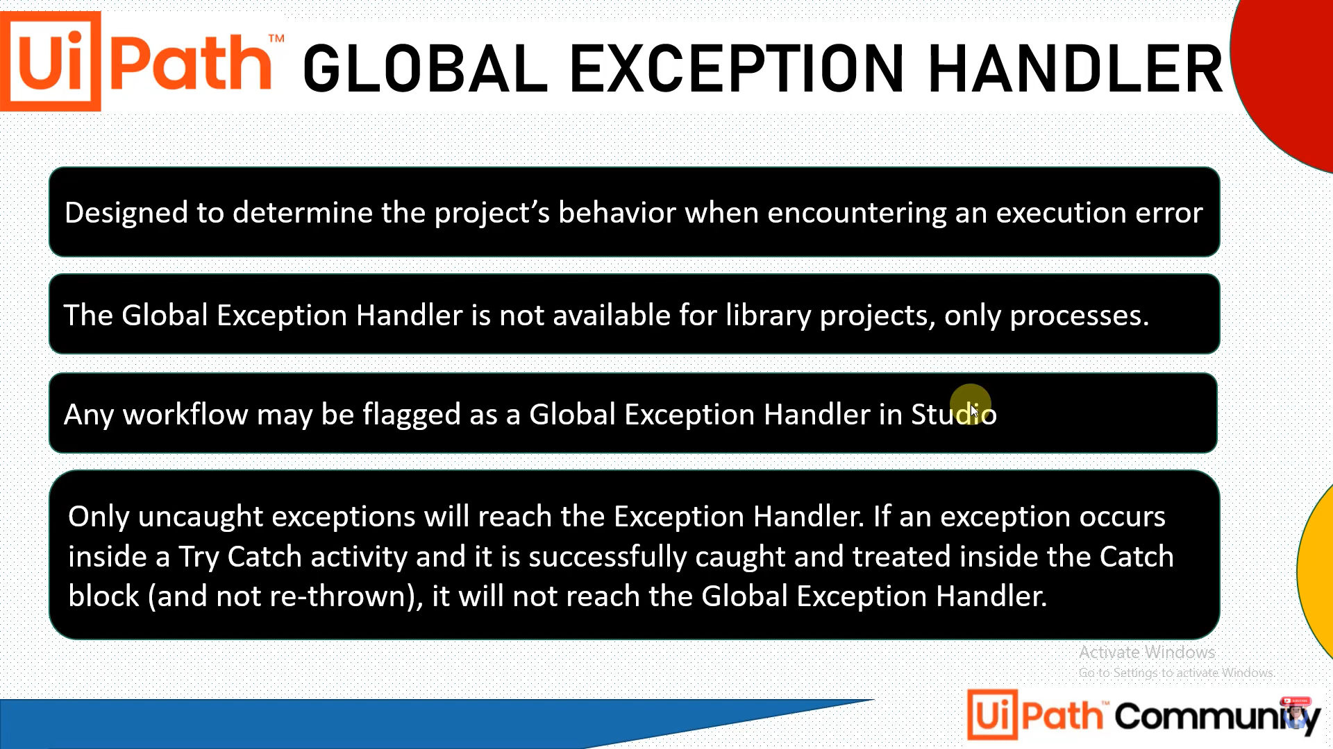

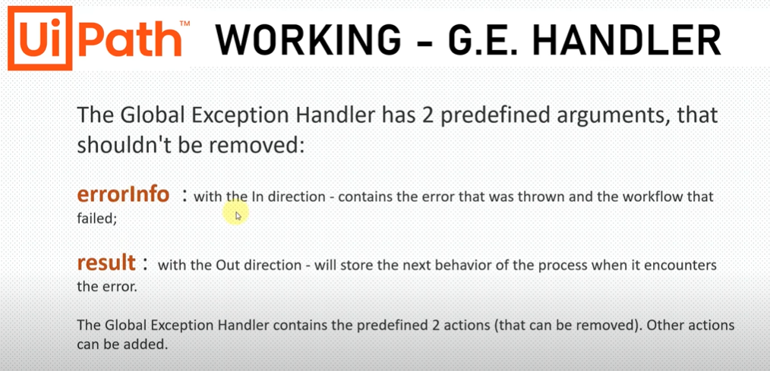

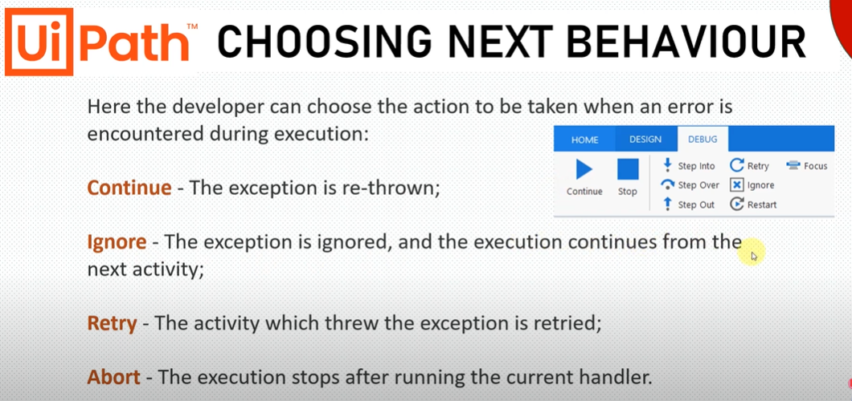

**State Machine Terminology:**

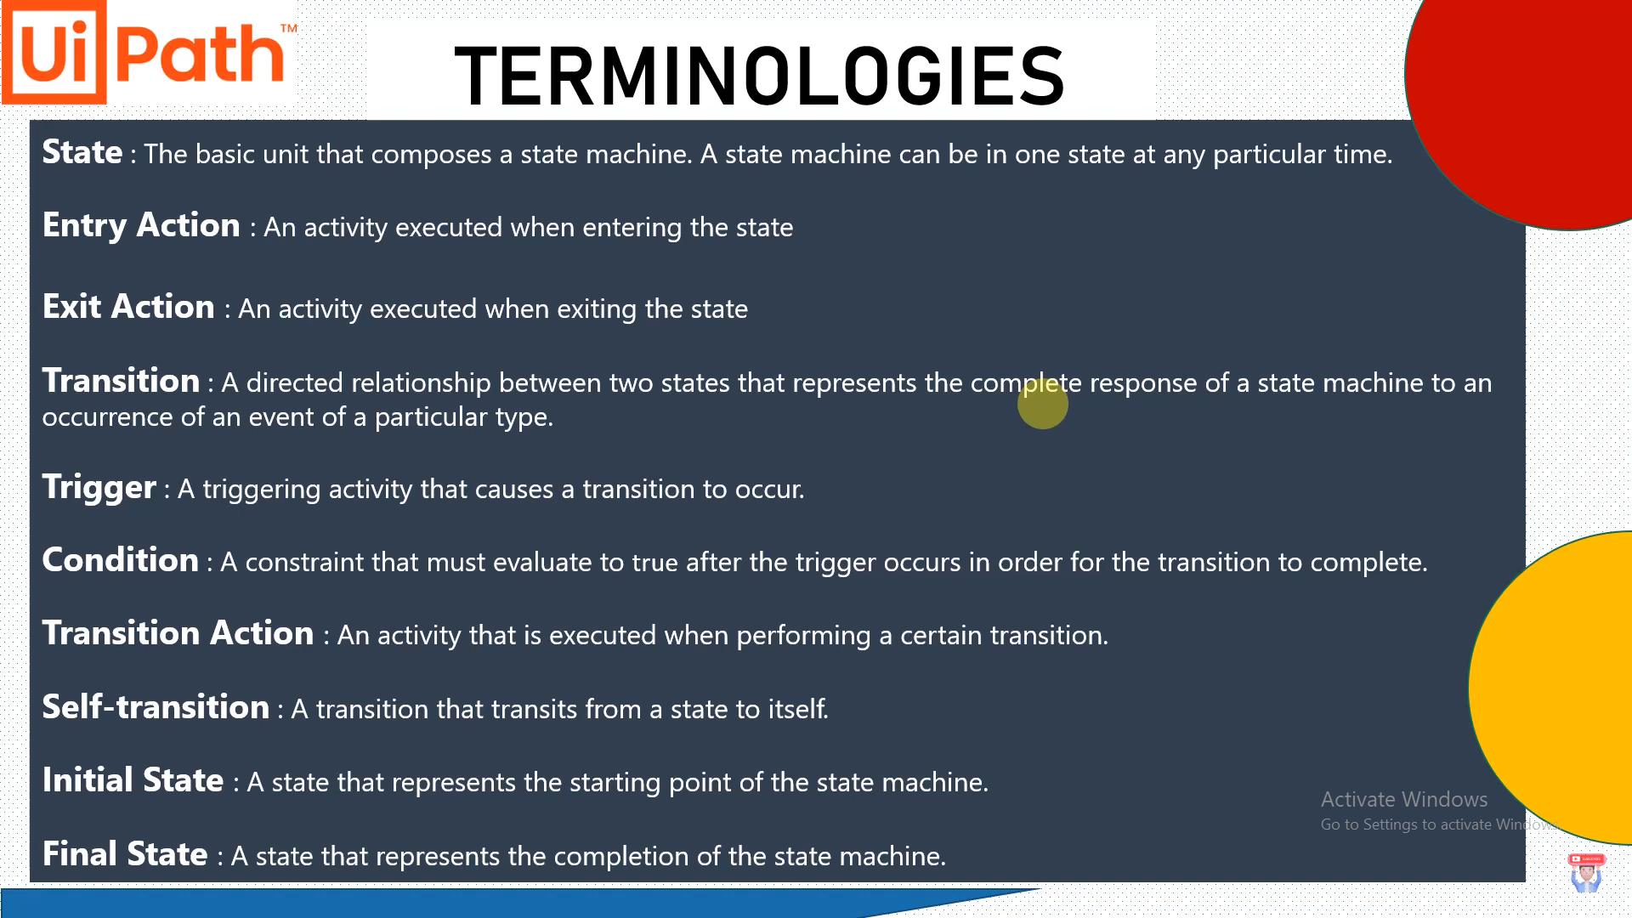

Sequences:

Sequences are the smallest type of project. They are suitable to linear processes as they enable you to go from one activity to another seamlessly, and act as a single block activity.

One of the key features of sequences is that they can be reused time and again, as a standalone automation or as part of a state machine or flowchart.

For example, you can create a sequence to take information from a .pdf file and add it to a spreadsheet, and reuse it in a different setting, while changing just a few properties.

Please take into consideration that whenever you wish to copy a large number of activities from one sequence to another, it is recommended to scroll down to the bottom of the Designer panel beforehand. This is due to a Windows Workflow Foundation limitation.

**NOTE:** Sequences do not use connectors.

Flowcharts:

Flowcharts can be used in a variety of settings, from large jobs to small projects that you can reuse in other projects.

The most important aspect of flowcharts is that, unlike sequences, they present multiple branching logical operators, that enable you to create complex business processes and connect activities in multiple ways.

Flowcharts come with the **Auto Arrange** option in the context menu.

# State Machines:

A state machine is a type of automation that uses a finite number of states in its execution. It can go into a state when it is triggered by an activity, and it exits that state when another activity is triggered.

Another important aspect of state machines are transitions, as they also enable you to add conditions based on which to jump from one state to another. These are represented by arrows or branches between states.

There are two activities that are specific to state machines, namely [State](https://docs.uipath.com/activities/docs/state) and [Final State](https://docs.uipath.com/activities/docs/final-state), found under **Workflow > State Machine**.

**NOTE:** You can only create one initial state, yet it is possible to have more than one **Final State**.

The **State** activity contains three sections, **Entry**, **Exit** and **Transition(s)**, while the **Final State** only contains one section, **Entry**. Both of these activities can be expanded by double-clicking them, to view more information and edit them.

The **Entry** and **Exit** sections enable you to add entry and exit triggers for the selected state, while the **Transition(s)** section displays all the transitions linked to the selected state.

**State Machine ChatGPT:**

In UiPath, a State Machine is a type of workflow that allows you to model complex business processes with multiple states and transitions. It is particularly useful for scenarios where there are different stages or states that an automation process can progress through based on certain conditions or events.

The State Machine workflow consists of the following components:

1. States: States represent different stages or steps in the automation process. Each state is a container that holds a set of activities. For example, you may have states like "Initialization," "Data Entry," "Validation," and "Completion."
2. Transitions: Transitions define the flow between states. They represent the conditions that need to be met for the automation process to move from one state to another. Transitions are associated with specific events or triggers, such as button clicks, data validation results, or time-based events.
3. Triggers: Triggers are events or conditions that initiate the transition from one state to another. They can be manual triggers, like user interactions, or automatic triggers, like the completion of a specific task or the occurrence of a certain event.
4. Actions: Actions are the activities that are executed within each state. They represent the specific tasks or operations that need to be performed at each stage of the automation process.

When working with a State Machine workflow, the automation process starts at an initial state. It then moves through different states based on the defined transitions and triggers. Each state can have its own set of actions that are executed when the automation process enters that state. Once the actions in a state are completed, the process evaluates the defined transitions to determine the next state to move into. This continues until the process reaches a final state or an end condition is met.

State Machines provide a visual representation of complex workflows and allow for clear modeling and tracking of business processes. They help in organizing the logic of an automation project and enable better control and flexibility in handling different scenarios and conditions.

When using State Machines in UiPath, it is important to carefully plan and define the states, transitions, triggers, and actions based on the requirements of the automation process. This ensures that the workflow accurately reflects the business logic and facilitates efficient and structured automation.

**Note:**

1. For excel automation we need to use all activities in **excel application scope** in classic design mode.
2. For excel automation we need to use all activities in **excel Process scope** in Modern design mode. We need to take **use excel file, Read Range workbbok** activity in excel process scope. In this use excel file we can use read range activity.

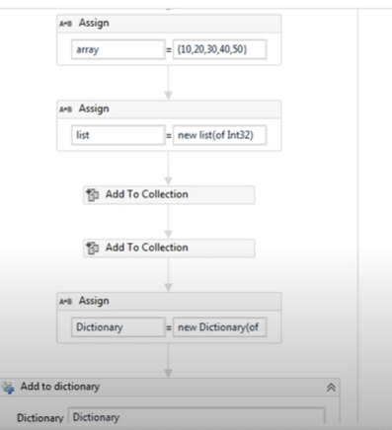

**Object having a property:Top of Form**

**We can filter the Data Table.**

**in_TransactionItem.SpecificContent("First Name").ToString** 🡪 we can get value from queue like this.

**Bulk add queue items** for adding data to the queue in orchestrator.

**IMAP Server Details:** when we want to read the mails. Stored in **List<MailMessages>**

**Server:** imap.gmail.com

Port: 993

**SMTP Server Details:** When we want to send the mail.

**Server:** smtp.gmail.com

Port: 465

* **Fuzzy selectors** (Dynamic) are more tolerant of changes in attributes and can still locate elements even if some attribute values vary.
* **Full selectors** provide a precise and complete description of an element and are suitable when the attributes of the target element remain static.

# Full Versus Partial Selectors

## Full selectors

* Contain all the elements needed to identify a UI element, including the top-level window
* Generated by the [Basic recorder](https://docs.uipath.com/studio/standalone/2022.10/user-guide/about-recording-types)
* Recommended when switching between multiple windows

Example of a full selector for the editable panel in Notepad:

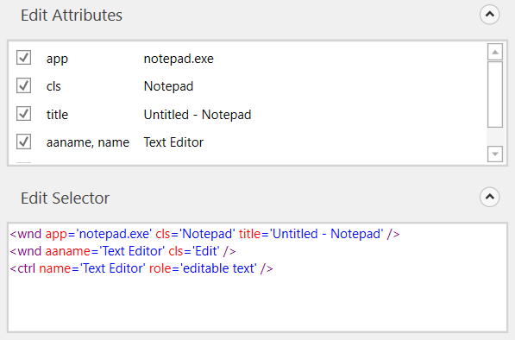

## Partial selectors

* Generated by the [Desktop recorder](https://docs.uipath.com/studio/standalone/2022.10/user-guide/about-recording-types)
* Do not contain information about the top-level window
* Activities containing partial selectors are enclosed in a container ([Attach Browser](https://docs.uipath.com/activities/docs/browser-scope) or [Attach Window](https://docs.uipath.com/activities/docs/window-scope)) that contains a full selector of the top-level window
* Recommended when performing multiple actions in the same window

Example of a partial selector for the editable panel in Notepad:

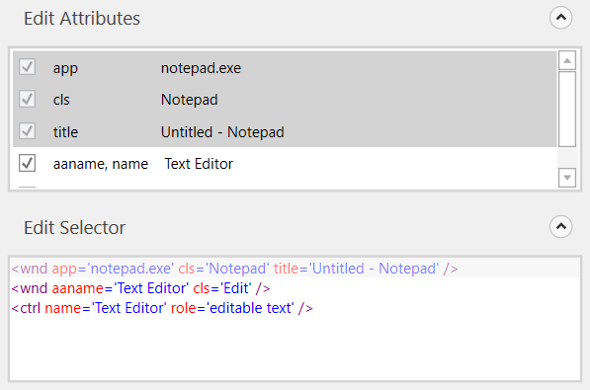

Selector Editor and UI Explorer display the full selector, not just the partial one. However, only elements belonging to the partial selector can be edited, the prepended ones are grayed out and read-only.

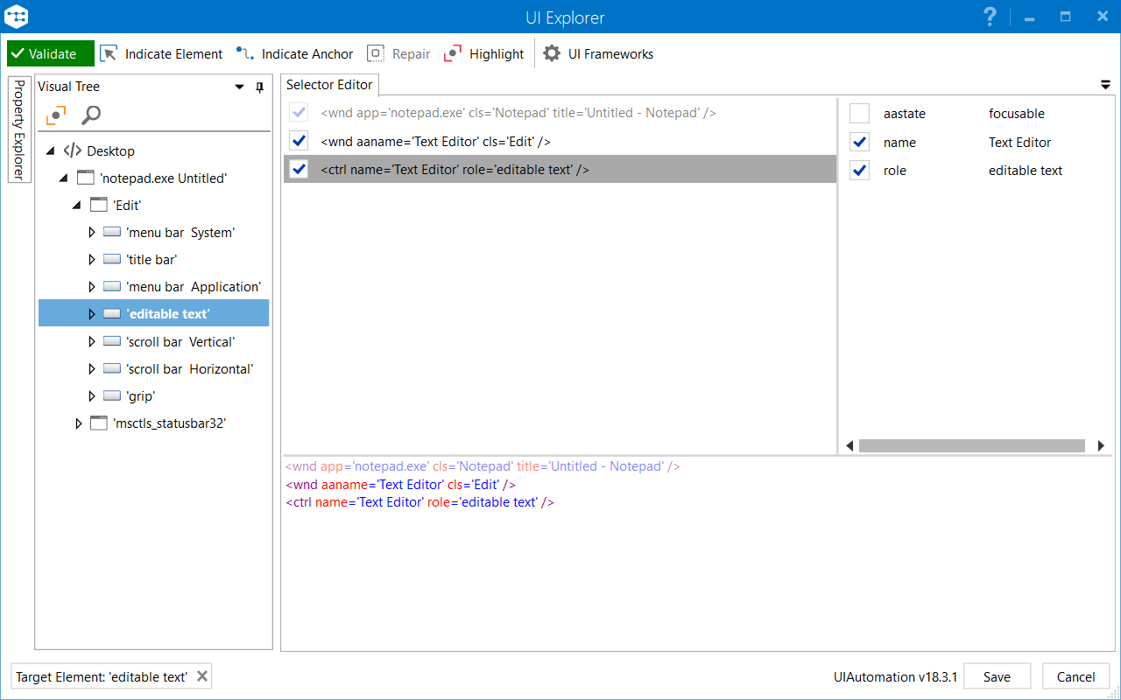

# Recording Types

There are five types of recordings available in UiPath Studio:

* **Basic** – Generates a full selector for each activity and no container. The resulted automation is slower than one that uses containers and is suitable for single activities.
* **Desktop** – Suitable for all types of desktop apps and multiple actions. It is faster than the **Basic** recorder, and generates a container (with the selector of the top-level window) in which activities are enclosed, and partial selectors for each activity.
* **Web** – Designed for recording in web apps and browsers, generates containers and uses the **Simulate Type/Click** input method by default.

**NOTE:** It is recommended to run your web automations on Internet Explorer 11 and above, Mozilla Firefox 50 or above, or the latest version of Google Chrome.

* **Image** – Used to record virtualized environments (such as VNC, virtual machines, Citrix, and more) or SAP. It permits only image, text and keyboard automation, and requires explicit positioning.
* **Native Citrix** - Is the equivalent of the **Desktop** recorder, but for Citrix environments. Only use this in your Native Citrix automation projects. Find out more about [Native Citrix Support](https://docs.uipath.com/studio/standalone/2022.10/user-guide/about-automating-citrix-technologies).

To see all the available types of recordings and select the one most suited for your project, click **Recording**, in the **Wizards** group of the **Design** ribbon tab.

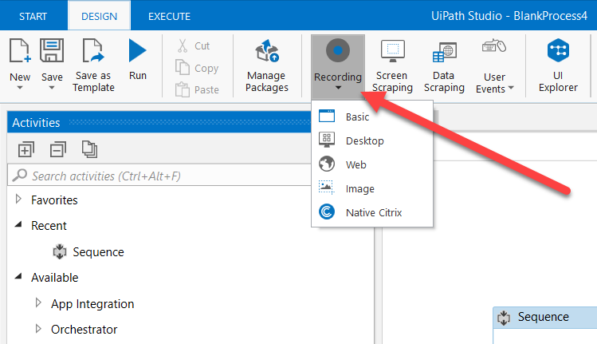

All recording types come with their own controllers (or toolbars) that give you access to actions particular to each environment, but also some common ones.

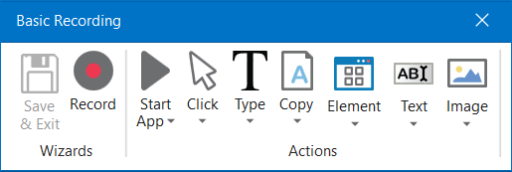

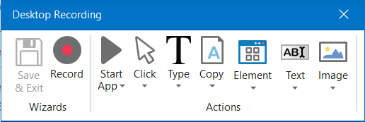

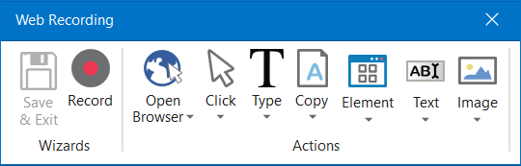

The **Desktop**, **Basic** and **Web Recording** toolbars are quite similar and enable you to:

* Automatically record multiple actions performed on the screen
* Manually record single actions, such as:
  + Starting or closing an application or web browser
  + Clicking an interface element
  + Selecting an option from a drop-down list
  + Selecting a check box
  + Simulating keystrokes or keyboard shortcuts
  + Copying text from a UI element or performing screen scraping
  + Looking for elements or waiting for them to vanish
  + Finding an image
  + Activating a window

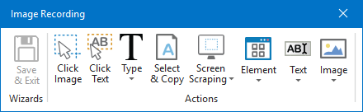

The **Image Recording** toolbar enables you to:

* Click an image or text
* Simulate keystrokes or hotkeys
* Select and copy text from a window
* Scrape UI elements
* Look for elements or wait for them to vanish
* Find an image or wait for it to vanish
* Activate a window

**NOTE:** The **Image Recording** toolbar supports only manual recording (single actions).

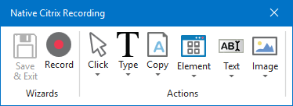

The **Native Citrix Recording** toolbar enables you to:

* Automatically record multiple actions performed on the screen
* Manually record single actions, such as:
  + Clicking an interface element
  + Selecting an option from a drop-down list
  + Selecting a check box
  + Simulating keystrokes or keyboard shortcuts
  + Copying text from a UI element or performing screen scraping
  + Looking for elements or waiting for them to vanish
  + Finding an image
  + Activating a window

| Automatic Recorder | Manual Recorder |
| --- | --- |
| * Left-click on windows, buttons, check boxes, drop-down lists etc. * Text typing | * Keyboard shortcuts * Modifier keys * Right-click * Mouse hover * Getting text * Find elements and images * Copy to Clipboard |

To figure out if you should use automatic or manual recording in your project, you should better understand the differences between the recording types and their capabilities.

Keyboard shortcuts that you can use while recording:

* F2 – pauses for 3 seconds. A countdown timer is displayed in the bottom left corner of the screen. Can be useful with menus that automatically hide.
* Esc – exits the automatic or manual recording. If you press the Escape key again, the recording is saved as a sequence, and you return to the main view.
* Right-click – exit the recording.

## **About Fuzzy Search: Fuzzy Selector**

A selector contains a top-level tag which references the target window or browser tab. It holds attributes like title, process name, URL, window name, and others, which help you properly identify the elements you want to use in your automation projects.

Often enough, top-level tag values are subject to dynamic changes because the target application rewrites them based on your actions. For example, a web page title can change during the automation process, which makes corresponding selector invalid.

In this regard, the selector’s fuzzy search capabilities enable you locate strings based on a pattern, rather than on an exact match to your input. This results in a more flexible method of identifying elements and validates selectors according to multiple attributes, even if some are prone to change during the automation process.

## How Fuzzy Search Works

In order to use the fuzzy search capabilities, a couple of matching options need to be included in the top-level tag of the target selector, as follows:

|  |  |
| --- | --- |
| Option | Description |
| matching:<tag_name>=fuzzy | Allows you to specify the target search tag, determined by the <tag_name> value. |
| fuzzyLevel:<tag_name>=<numerical_value> | Determines the matching threshold for the target <tag_name>. It supports a numerical  value from 0 to 1, as follows:  - Closer to 0 - returns results with lower similarity to the <tag_name>  - Closer to 1 - returns results with higher similarity to the <tag_name> |

**NOTE:** If more elements are found, the target action is executed on the first one.

**NOTE:**

Adding check:text="example" in a fuzzy selector checks if the target element contains the specified text.

For example, adding check:text="Options" to a fuzzy selector checks if the target element contains the Options text.

## **Examples of Using Fuzzy Search**

Fuzzy Search can be used to identify nearly any type of attribute in the top-level tags of selectors. In the following examples, we aim to build valid selectors with attributes which is incorrectly spelled.

##### **A. Using a High Fuzziness Level**

Let's assume we want to build a selector to identify the W3Schools Online Web Tutorials <title> attribute. For the purpose of our example, the attribute is incorrectly spelled, thus making the selector invalid.

<html app='firefox.exe' title='WEScho0ls Online Web Tutorials' />

To fix this, we need to introduce Fuzzy Search inside the <html> tag. Since the attribute of interest is <title>, the <tag_name> of our Fuzzy Search expression needs to have the matching:title=fuzzy form. The mistake in our <title> attribute is small, so we can use a fuzziness level closer to 1. The following selector is generated, which returns the correct <title> attribute, which, in this case is W3Schools Online Web Tutorials:

<html app='firefox.exe' title='WEScho0ls Online Web Tutorials'

matching:title='fuzzy' fuzzylevel:title='0.8' />

##### **B. Using a Low Fuzziness Level**

In this second example, we need to build selectors for an <aaname> attribute. The target attribute is Colorpicker, but in our example it is incorrectly spelled Clorker. Needless to say that, with an incorrectly spelled attribute, our selector is invalid, and looks something like this:

<html title='W3Schools Online Web Tutorials' />

<webctrl aaname='Clorker' parentid='main' tag='IMG' />

The Fuzzy Search needs to be included in the <webctrl> tag. In this case, our target is <aaname>. Since there are more mistakes in the spelling of our target, we reduce the fuzziness level closer to 0, so that there are greater chances of accurate detection. The following selector is generated, which returns the correct <aaname> attribute, which, in this case is Colorpicker:

assignment

<html title='W3Schools Online Web Tutorials' />

<webctrl aaname='Colorker' parentid='main' tag='IMG' matching:aaname='fuzzy' fuzzylevel:aaname='0.4' />

Eg.

<html title='W3Schools' />

<html> 🡪 Tag

title 🡪 Attribute. **'W3Schools' 🡪** Value of title attribute.

**UIExplorer**

**UI Explorer** is an advanced tool that enables you to create a custom selector for a specific UI element.

This comes in handy when you want to make sure that an application can be automated with selectors. It enables you to simply inspect elements without building a process.

To open the **UI Explorer** window, click the button in the **Selectors** section, in the **Design** tab, or from the advanced editor in the selection screen of all the selectors of the **target** and **anchors** attributes, after indicating the target UI element.

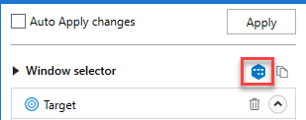

**NOTE:** If you do not have the UiPath.UIAutomation.Activities pack installed as a dependency for the current project, the **UI Explorer** button does not appear in the **Ribbon**.

Alternatively, the **UI Explorer** can be launched from the **Tools** page in the Studio backstage view. UI Explorer from the context menu uses the UI automation libraries shipped with the current version of Studio.

**NOTE:** The version of the UIAutomation package that is currently used is displayed in the lower right corner in the **UI Explorer** you have opened. This version varies, as launching the **UI Explorer** from the **Tools** page uses the default **UI Automation** version shipped with the Studio version you are using, while opening **UI Explorer** from the **Ribbon** uses the version you have installed as a dependency for the current project.

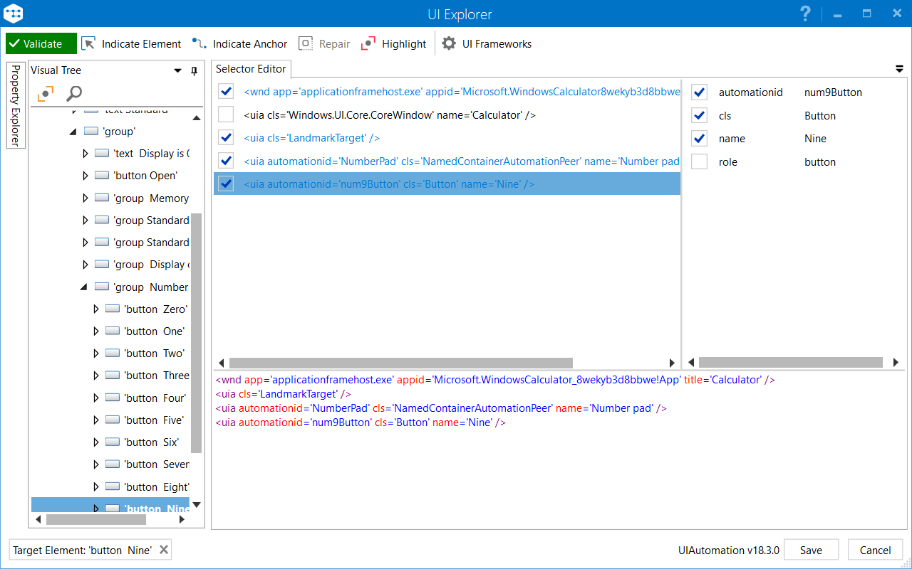

|  |  |
| --- | --- |
| Field | Description |
| **Validate** | The button shows the status of the selector by checking the validity of the selector definition and the visibility of the target element on the screen.  The **Validate** button has three states:   * https://documentationpicturerepo.blob.core.windows.net/screenshots/screenshots/2018.3_Studio/buttonLoading2.jpg Selector is being validated * https://documentationpicturerepo.blob.core.windows.net/screenshots/screenshots/2018.3_Studio/status_valid_selector.png Valid selector * https://documentationpicturerepo.blob.core.windows.net/screenshots/screenshots/2018.3_Studio/status_invalid_selector.png Invalid selector * https://documentationpicturerepo.blob.core.windows.net/screenshots/screenshots/2018.3_Studio/2018-09-24_12-34-38.png Modified selector, revalidate |
| **Indicate Element**  https://documentationpicturerepo.blob.core.windows.net/screenshots/screenshots/2018.3_Studio/indicate_element.png | Indicates a new UI element to replace the previous one. |
| **Indicate Anchor**  https://documentationpicturerepo.blob.core.windows.net/screenshots/screenshots/2018.3_Studio/indicate_anchor.png | Enables you to choose an anchor relative to the target UI element. |
| **Repair**  https://documentationpicturerepo.blob.core.windows.net/screenshots/screenshots/2018.3_Studio/repair.png | Enables you to re-indicate the same target UI element and repair the selector. This operation does not completely replace the previous selector. The button is available only when the selector is invalid. |
| **Highlight**  https://documentationpicturerepo.blob.core.windows.net/screenshots/screenshots/2018.3_Studio/highlight.png | Brings the target element in the foreground. The highlight stays on until it's switched off. The button is enabled only if the selector is valid. |
| **UI Frameworks**  https://documentationpicturerepo.blob.core.windows.net/screenshots/screenshots/2018.3_Studio/ui_frameworks.png | Changes the technology used to determine UI elements and their selectors. The following options are available:   * Default – UiPath proprietary method. Usually works fine with all types of user interfaces. * Active Accessibility – an earlier solution from Microsoft for making apps accessible. It is recommended that you use this option with legacy software, when the Default one does not work. * UI Automation – the improved accessibility model from Microsoft. It is recommended that you use this option with newer apps, when the Default one does not work.   Click [here](https://docs.microsoft.com/en-us/dotnet/framework/ui-automation/ui-automation-and-microsoft-active-accessibility) to read more about Active Accessibility and UI Automation. |
|  |  |
|  |  |

## The Visual Tree Panel

Displays a tree of the UI hierarchy and enables you to navigate through it, by clicking the arrows in front of each node.

By default, the first time when you open **UI Explorer**, this panel displays all opened applications, in alphabetical order.

Double-clicking a UI element (or right-clicking and selecting **Set as Target Element**) from the tree, populates the **Selector Editor**, **Selector Attributes** and **Property Explorer** panels.

## The Selector Editor Panel

Displays the selector for the specified UI object and enables you to customize it.

The bottom part of the panel displays the actual XML fragment that you have to use in a project. Once you find the selector you want, you can copy it from here and paste it in the **Properties** panel of an activity, in the **Selector** field.

The top part of this panel enables you to view all the nodes in a selector and eliminate the ones that are not necessary by clearing the check box in front of them. An element in the list of selector nodes becomes active when you enable or disable an attribute, or when editing a selector in the bottom panel. Only one node is active at a time.

Selecting a node here displays its attributes in the **Selector Attributes** and **Property Explorer** panels.

Selectors can also be edited with the aid of variables, either by using the CTRL+K hotkey to create a variable in the selector itself, or by specifying an already created variable with the CTRL+Space combination. Using the CTRL+K hotkey enables you to specify a value and a name for the variable. Please note that only string variables can be used.

## The Selector Attributes Panel

Displays all the available attributes of a selected node (from the **Selector Editor** panel).

You can add or eliminate some of the node attributes by selecting or clearing the check box in front of each attribute.

Additionally, you can change the value of each attribute yet this modification is retained only if the new selector points at the originally selected UI object.

## The Property Explorer Panel

Displays all the attributes that a specified UI object can have, including the ones that do not appear in the selector. They cannot be changed.

# Selectors with Wildcards

Wildcards are symbols that enable you to replace zero or multiple characters in a string. These can be quite useful when dealing with dynamically-changing attributes in a selector.

* Asterisk (*) – replaces zero or more characters
* Question mark (?) – replaces a single character
* Asterisk AND Question mark (*?) - matches an attribute value with at least one character

# Dynamic Selectors

A dynamic selector uses a variable or an argument as a property for the attribute of your target tag. This allows the selector to easily identify a target element based on the value of the variable or argument, and not an exact string, which might change, depending on interactions inside your automation project. As such, the variable or argument can be changed to interact with a different element, without changing the selector itself. A dynamic selector has the following form, with the specifications:

* **tag** - the target tag, such as <ctrl/>
* **attribute** - the target attribute, such as name='menuItem'
* **{{Value}}** - the name of the variable or argument which holds the property of the element you want to interact with

**Dynamic Selector Format:**

<tag attribute=<code>{{Value}}</code> />

## Example of Using a Dynamic Selector

To illustrate the functionality of a dynamic selector, we create a simple automation process which performs a click on the **File** menu in Notepad. We then change the variable so that the **Format** menu is then clicked, but without modifying the selector.

**NOTE:** The following example uses a **variable**. Please note that **arguments** are also supported.

1. Create a new process in Studio, and add a **Click** activity.
2. Choose to **Indicate on screen** and select the **File** menu in Notepad. The following selector is generated:
3. <wnd app='notepad.exe' cls='Notepad' title='Untitled - Notepad' />
4. <ctrl automationid='MenuBar' idx='1' name='Application' role='menu bar' />

<ctrl name='File' role='menu item' />

1. Select and right-click the File property of the name attribute. A context menu with several options is displayed.
2. From the context menu, choose to **Create variable**. A couple of fields appear, allowing you to specify the variable name and value.
3. Specify a name for the new variable in the **Set Name:** field, which, in our case is **MenuOption**. Leave the **Set Value** field as is, so that the selector knows to click the attribute with the File property.
4. Click the **Validate** button in the **Selector Editor** window. Notice it turns green, which means our selector is valid. As such, the following dynamic selector is generated:
5. <wnd app='notepad.exe' cls='Notepad' title='Untitled - Notepad' />
6. <ctrl automationid='MenuBar' idx='1' name='Application' role='menu bar' />

<ctrl name='{{MenuOption}}' role='menu item' />

The generated selector now instructs the **Click** activity to perform the action on the **File** menu. To have it click the **Format** menu, for instance, you only need to change the default value of the variable. In this example, the operation requires a single step:

* Access the **Variables** panel in Studio and change the **Default** value of the **MenuOption** entry to **Format**. The **Click** activity now performs the action on the **Format** menu in Notepad. Note that the selector is already validated and you can start your automation process, which now clicks the **Format** menu instead of **File**.

**RE Framework:**

**Default Variables in RE Framework:**

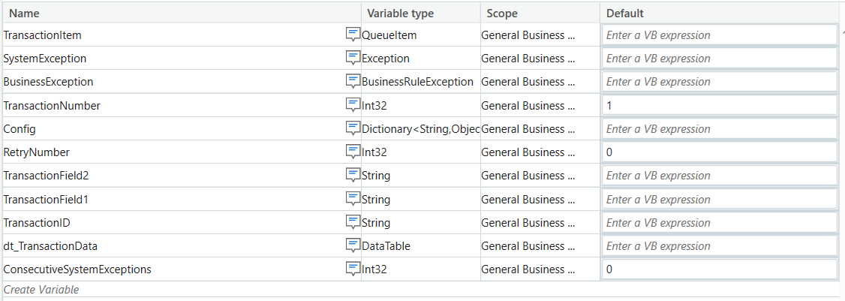

**Default Workflows available:**

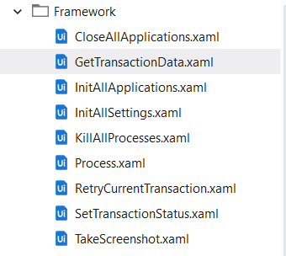

**State Invoked Workflows**

**Initialization**

InitAllSettings.xaml

KillAllProcesses.xaml

InitAllApplications.xaml

**Get Transaction Data**

GetTransactionData.xaml

**Process Transaction**

Process.xaml

SetTransactionStatus.xaml

• RetryCurrentTransaction.xaml

• TakeScreenshot.xaml

• CloseAllApplications.xaml

• KillAllProcesses.xaml

**End Process**

CloseAllApplications.xaml

KillAllProcesses.xaml

Each state invokes one or more workflows, which are listed in Table 2 and detailed in the section Workflows.

**States in RE Framework:**

**1) Initialization**

**By default, Variables available:**

* 1. SystemException 🡪 variable type is exception
  2. Config 🡪 variable type is dictionary<string,object>

**By Default, Arguments available:**

1. In_OrchestratorQueueName
2. In_OrchestratorQueueFolder

Three sheets available in config.xlsx file in data folder.

1. Setting
2. Constant
3. Asset 🡪 we need to give asset name which is available in orchestrator

**Note:** We have to store credential Asset in setting sheet.

Three columns are available in setting and constant sheet.

🡪 **Name, Value, Descriptions.**

How to get value from config file?

* Config(“Key Name”).ToString

Workflows available in Initialization state:

1. InitAllSettings.xaml
2. KillAllProcesses.xaml
3. InitAllApplications.xaml

This state is completely depending on **System Exception**.

**Note:** If we got **System Exception**, then it will go to **End Process** state else it will go to **Get Transaction Data** state.

**2) Get Transaction Data:**

**Variables:** Highlighted/first variables in with queue or without queue is mandatory other variables are optional.

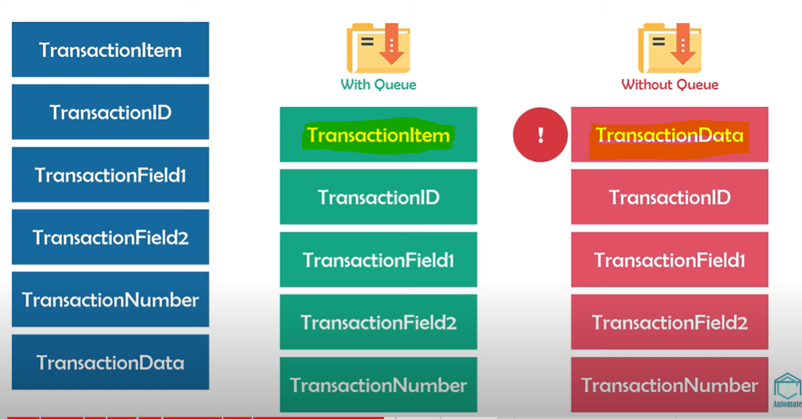

**How to get data from queue?**

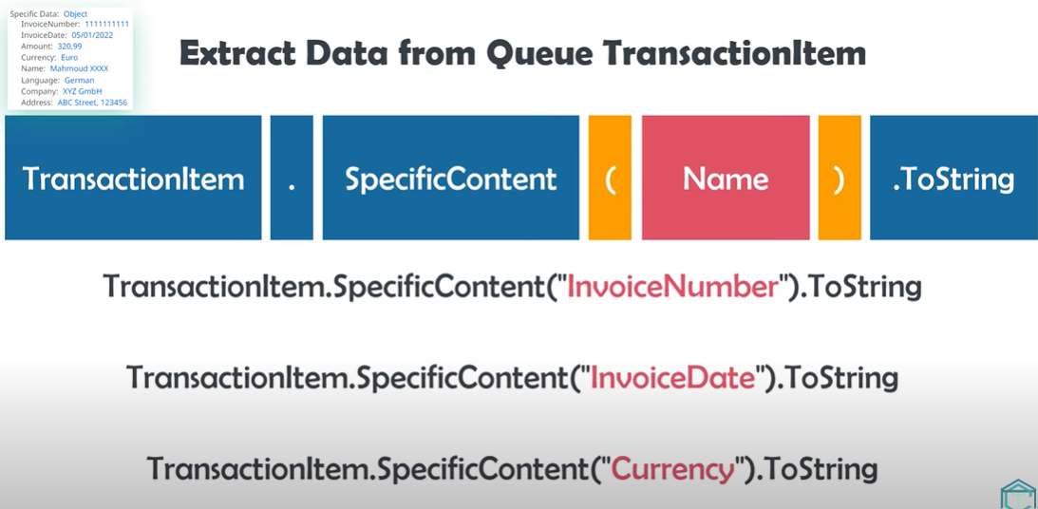

**Note: Check stop signal activity**🡪 If someone gave stop signal through the orchestrator then it will go to the ShouldStop variable data type is Boolean.

Then it will set transaction item variable value to the Nothing. That’s why execution will stop.

Get Transaction Data state is completely depending on **TransactionItem** variable. If TransactionItem variable is **not nothing**(we have the transaction data) then it will go to the **Process Transaction** State else it will go to the **End process** state because don’t have any data in TransactionItem variable.

Workflows available in Get Transaction Data state:

* GetTransactionData.xaml

**3) Process Transaction:**

**Variables:**

* 1. BusinessException🡪 Variable type is BusinessRuleException.
  2. RetryNumber 🡪 variable type is Int32. Default value is 0.

**Workflows available:**

1) Process.xaml

2) SetTransactionStatus.xaml

• RetryCurrentTransaction.xaml

• TakeScreenshot.xaml

• CloseAllApplications.xaml

• KillAllProcesses.xaml

This workflow is completely depending on below variables:

1. SystemException 🡪 If System Exception is there then it will go to the Initialization state.
2. BussinessException 🡪 If Business Exception is there then it will go to the Get Transaction Data state.
3. Success(Don’t have any exception): It will go to the Get Transaction Data state.

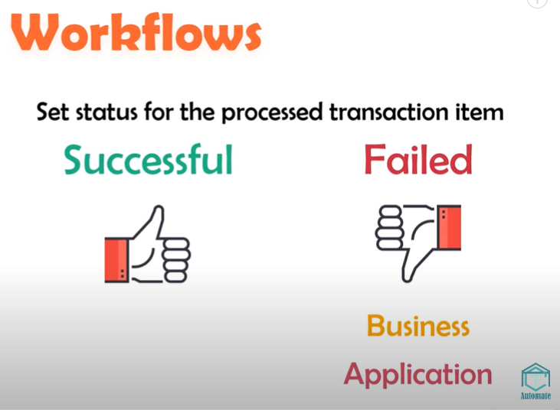

**ReTry variable:**

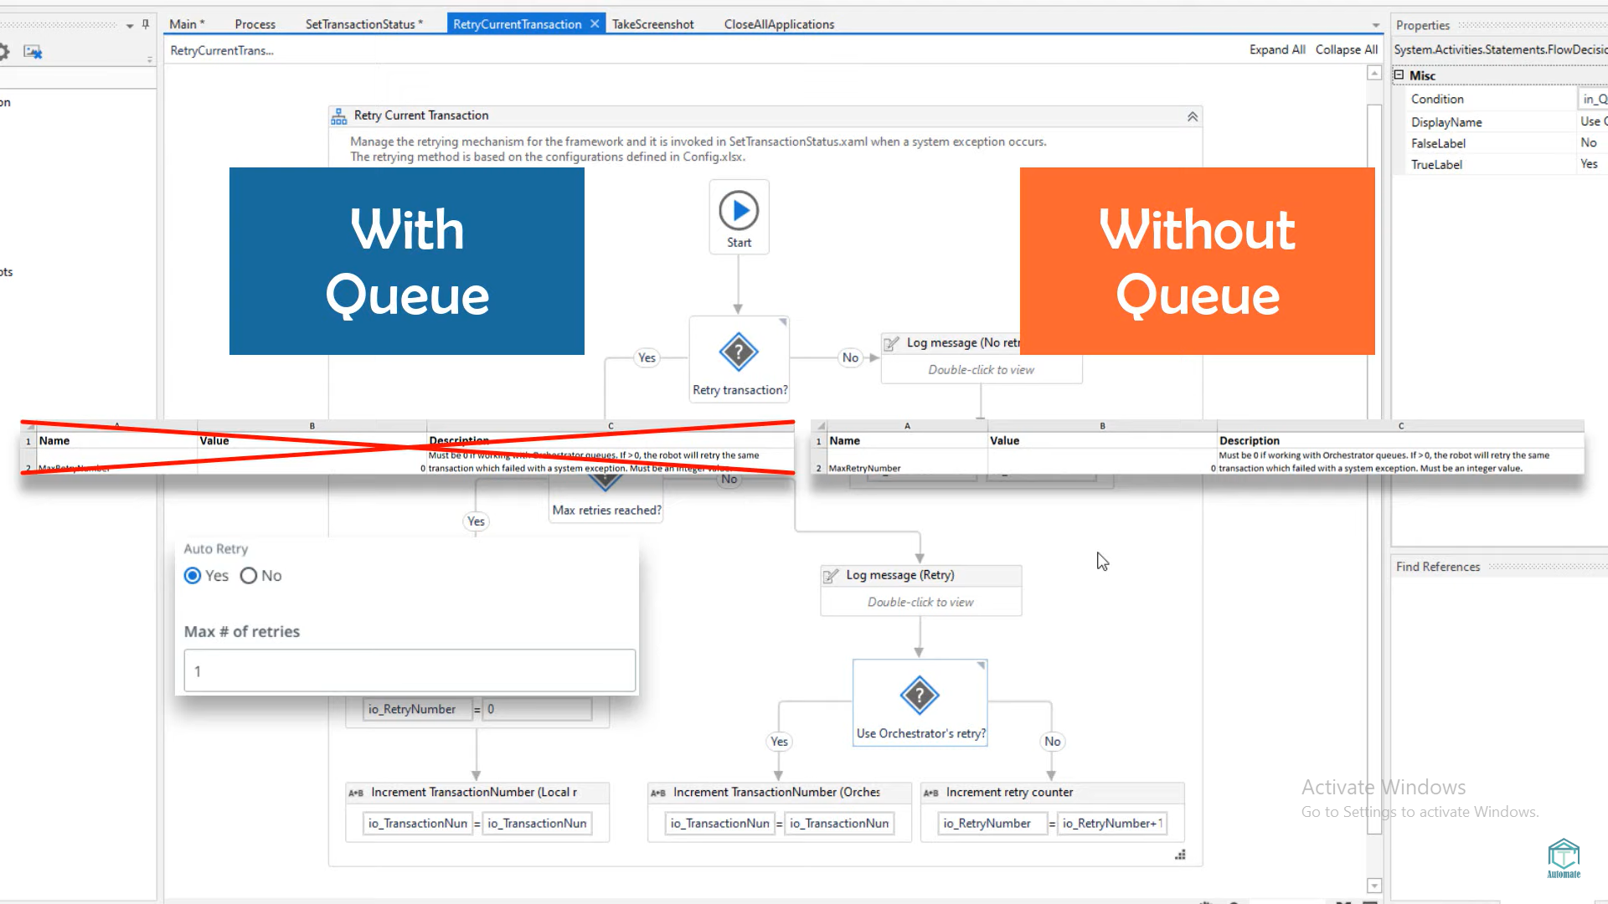

**4) End Process:**

Workflows available:

1. CloseAllApplications.xaml
2. KillAllProcesses.xaml

**State Machine:**

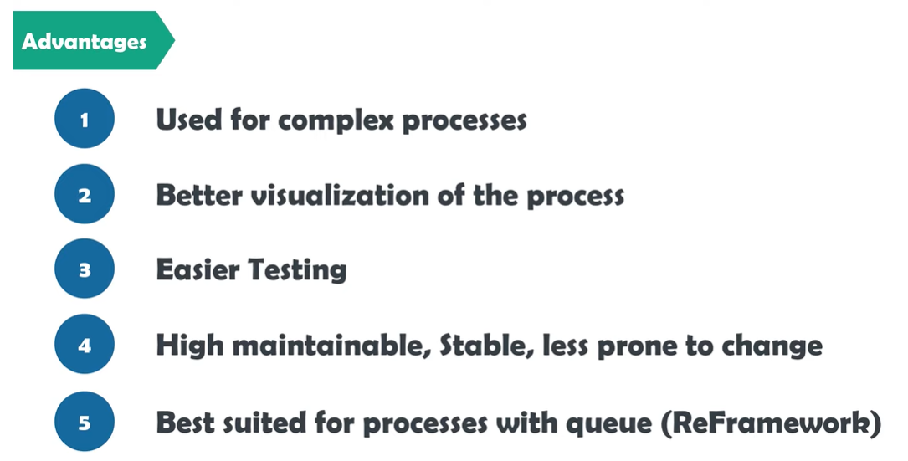

**Difference between Sequence, Flowchart and State Machine**

**Sequence:🡪** Simple linear representation of process.

* + - It will execute top to bottom one by one.

**Flowchart:🡪** It will more flexible for connecting activities.

* + - Here we can use multiple branching logical operator which enable us to create complex business process and connect activities with multiple ways.
    - It will have used in that process have multiple decision points.

**State Machine:🡪** It is the event driven process.

* + - It is based on finite number of states and transitions.
    - It is also called as finite state machine.
    - It is best suited for complex and continue process.
    - In state machine we can declare only one Initial state but we can add multiple Final states.

**States in state machine:**

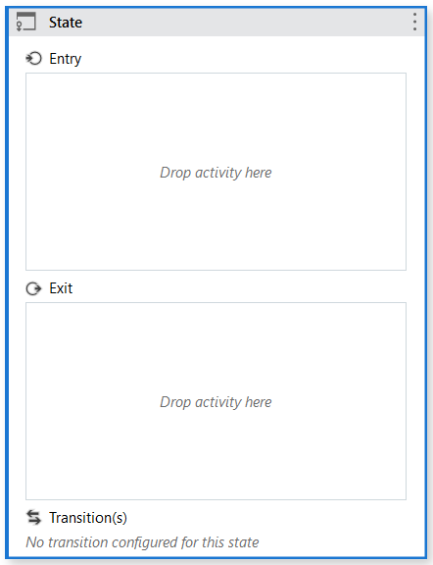

**Note:**

1) In Final state we have only Entry state don’t have exit and transition state.

2) Entry will execute each and every time when we enter in the state.

3) Exit will execute only when we have declared the transition and we can go to the next state. (At the time of leaving the state.)

**In Transition state is depending on below things:**

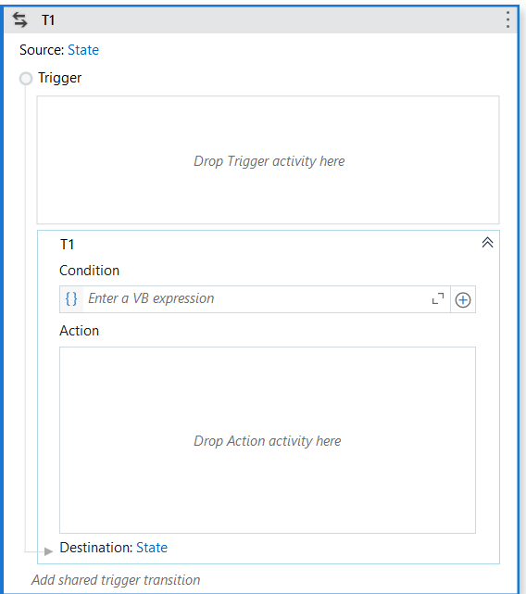

**How to store values in Dictionary?**

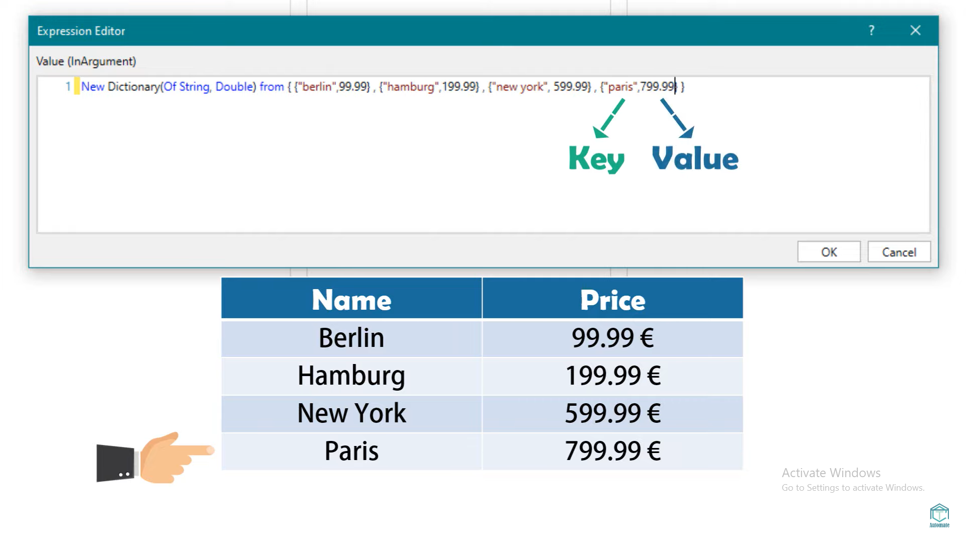

**Exception Handling in UiPath:**

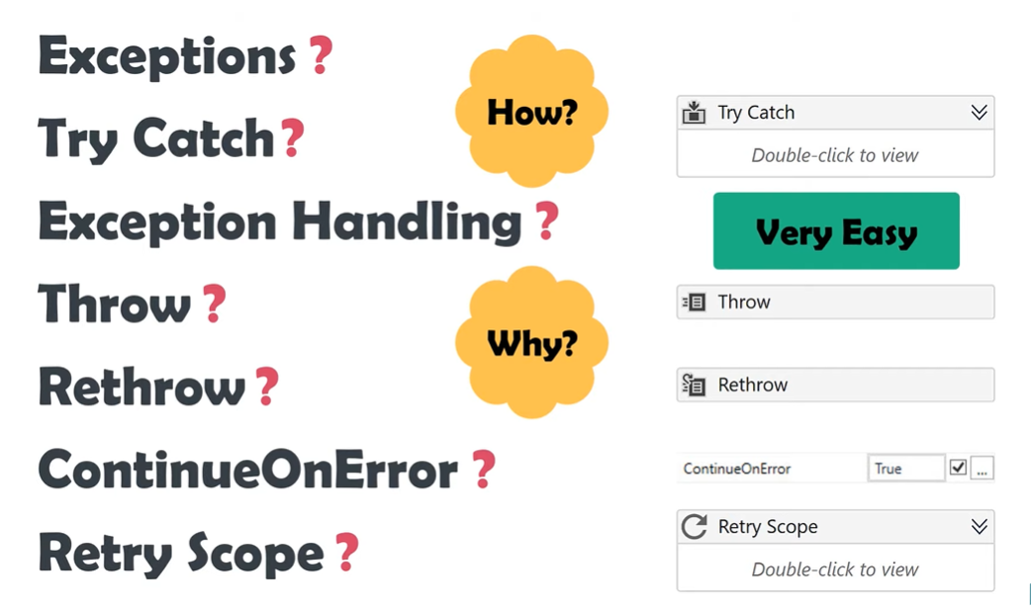

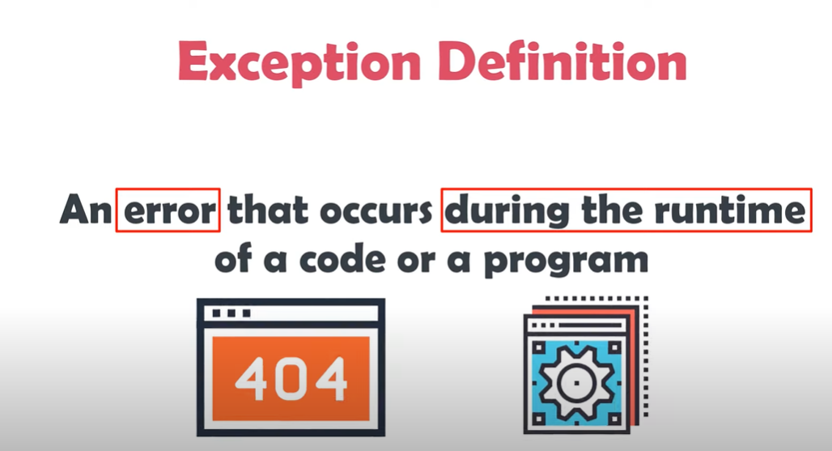

**Try Catch Activity:**

**Try Catch**

System.Activities.Statements.TryCatch

**Description**

Catches a specified exception type in a sequence or activity, and either displays an error notification or dismisses it and continues the execution.

There is no limit to how many **Catches** you can use in a **Try Catch** activity. This activity requires at least one catch to be added.

**Configuration**

The activity body contains three fields:

* **Try** - The activity performed which has a chance of throwing an error.
* **Catches** - The activity or set of activities to be performed when an error occurs.
  + **Exception** - The exception type to look for. You can add multiple exceptions.
* **Finally** - The activity or set of activities to be performed after the **Try** and **Catches** blocks are executed. This section is executed only when no exceptions are thrown or when an error occurs and is caught in the **Catches** section.

**NOTE:**

* + If an activity is included in the **Try** section, and the value of the **ContinueOnError** property is True, no error is caught when the project is executed.
  + The **Try Catch** activity does not catch fatal exceptions such as:
    - FatalException
    - OutOfMemoryException
    - ThreadAbortException
    - FatalInternalException

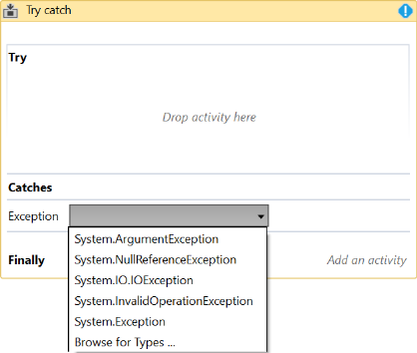

**Properties**

* **DisplayName** - The display name of the activity.
* **Private** - If selected, the values of variables and arguments are no longer logged at Verbose level.

**NOTE:** Pressing “Ctrl + T” places the selected activity inside the **Try** section of a **Try Catch** activity.

**Throw and Rethrow:**

**Throw Activity:** The "Throw" activity is used to raise a custom exception. It allows you to define your own exception message and type, which can be helpful for debugging and providing meaningful error messages to users. When the "Throw" activity is executed, it immediately stops the execution of the workflow and propagates the exception to the nearest exception handler or the main workflow, if no exception handler is found. In other words, it throws an exception that must be caught and handled.

- Throwed exception must be handled in Catch block

**Rethrow Activity:** The "Rethrow" activity is used within a "Catch" block to rethrow the caught exception to an outer exception handler or the calling workflow. It's particularly useful when you want to perform some specific actions within the "Catch" block but still want the exception to be handled by a higher-level (Parent level) exception handler.

By using "Throw" and "Rethrow" activities in your UiPath workflows, you can control the flow of exceptions and handle them appropriately to build more robust and reliable automation solutions.

Types of Asset:

1. Credential 🡪 contains usernames and passwords that the Robot requires to execute particular processes, such as login details for Gmail, facebook.
2. Text🡪 stores only strings (it is not required to add quotation marks)
3. Boolean 🡪 supports true or false values
4. Integer 🡪 stores only whole numbers

**Macro in Excel Automation:**

**What is Macro:** If you have tasks in Microsoft Excel that you do repeatedly, you can record a macro to automate those tasks. A macro is an action or a set of actions that you can run as many times as you want. When you create a macro, you are recording your mouse clicks and keystrokes.

- Macro will record our repetitive task and after that it will work auto.

- Macro will support only **.xlsm** extension excel file.

Examples of Macro:

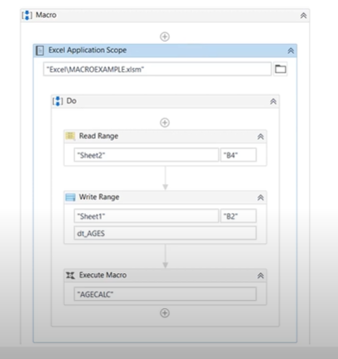

Three Tab in UiPath Studio:

1. Home 2) Design 3) Debug

**LINQ Query: Convert DataTable variable to Dictionary**

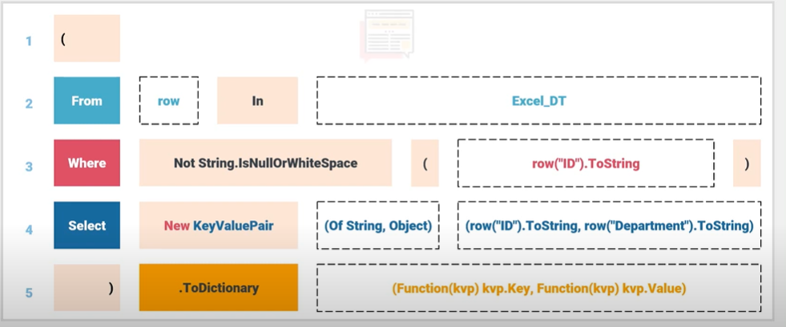

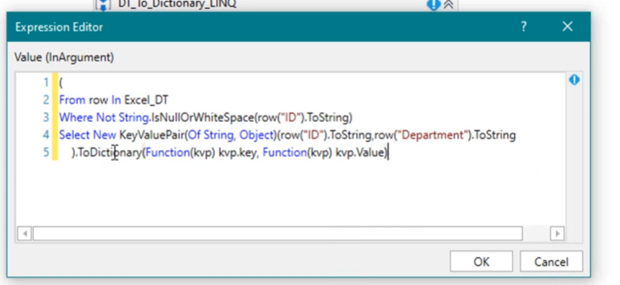

Write above query in assign activity to convert datatable variable to dictionary variable.

Dict(variable type dictionary)= above query. It will convert Datatable to dictionary.

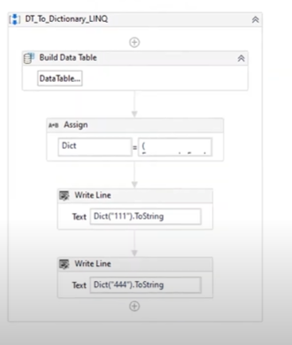

**How to filtered data table using function or LINQ**

FilteredDataTable = dt_ExtractDataTable.AsEnumerable().Where(function(row) cdbl(row("AUM").ToString)>2000).CopyToDataTable()

- FilteredDataTable 🡪 variable type is DataTable

- dt_ExtractDataTable 🡪 Extracted data from website. Variable type is DataTable.

How to convert RE Framework for Data Table: Steps.

1. Kill all applications which is required in automation before start the automation in kill all process xaml.
2. open all applications which is required in automation before start the automation in InIt all application xaml.
3. Use config file for all the changeable part. Don’t hard code. Like file path, url, email, etc.
4. Read excel file in first run in initialization state. In if block where **condition is = Config is Nothing**
5. Output of excel is DataTable variable. If you have created separate sequence for the Data Reading purpose, then you should assign that Data table variable value to one DataTable argument as out direction.
6. In GetTransaction Data state. Change **TransactionItem** variable type from queueItem to DataRow.
7. In GetTransaction Data state, and GetTransaction Data.xaml disable or remove the get transaction item activity.
8. Instead of that activity take one if activity and in that activity give condition as **in_TransactionNumber<=io_dt_TransactionData.Rows.Count** In if activity take assign activity and assign **out_TransactionItem = io_dt_TransactionData(in_TransactionNumber-1)**

* **out_TransactionItem 🡪** Variable type is Data row
* **io_dt_TransactionData 🡪** Variable type is DataTable
* **in_TransactionNumber** 🡪Variable type is int. default=1.
* DataTable variable index starts with 0 that’s why we mentioned in_TransactionNumber-1.
* In else we have to take assign activity and assign value Nothing to the **out_TransactionItem = Nothing.**

1. Change **outTransactionItem** variable type from queue item to DataRow in GetTransactionData.xaml.
2. Click on import arguments and assign **outTransactionItem = TransactionItem.**
3. If still facing some error in GetTransactionItem.xaml then instead of old assign activity take new assign activity and assign **TransactionItem=Nothing.**
4. As of now our Initialization and Get Transaction Data states are done.
5. In Process Transaction State, open process.xaml and change **in_TransactionItem** variable data type from QueueItam to DataRow
6. In Import argument for process.xaml assign **in_TransactionItem= TransactionItem.**
7. In SetTransactionStatus.xaml change the In_TransactionItem variable data type to DataRow.
8. After that we need to disable some activities in success, business exception and system exception activity, because that activity is required to set the transaction status in Orchestrator queue.

**Note:**

**vbLf 🡪** It will help us to give line feed/Next line. Like \n in C Language.

**What language is UiPath built on?**

**🡪**

UiPath is in built with c# and dot net.

Although most of the functions are compatible with both, it is easy to cope with the activities while using methods/functions from VB.Net. UiPath is not built on VB.NET. Most of the code is written in C#, not that it matters since they are both . NET language.